

Core Collection – Charter School Waitlist (CSW)

- Responsibilities and Requirements
- Required TSDS Roles
- DMC L1.5 Filters
- DMC L2 Validations
- Promoting CSW Data
- Validating CSW Data (L3 Validations)
- Verifying CSW Report
- Preparing/Finalizing CSW Data



TSDS Charter School Waitlist (CSW) Core Collection

TSDS CSW – Submission Purpose, Responsibilities & Requirements

The purpose of the Charter School Waitlist Collection is to meet the requirements of TEC Chapter 12, Subchapter D, Section 12.1174 by collecting information about enrollment and the use of a waiting list as of the last Friday in September.

CSW data consists of two Domains; Education Organization and Student Application and is reported to TEA as a Core Collection.

Districts will send their CSW data collection through the TSDS Portal in TEAL.

2024-2025 CSW Submission Timeline

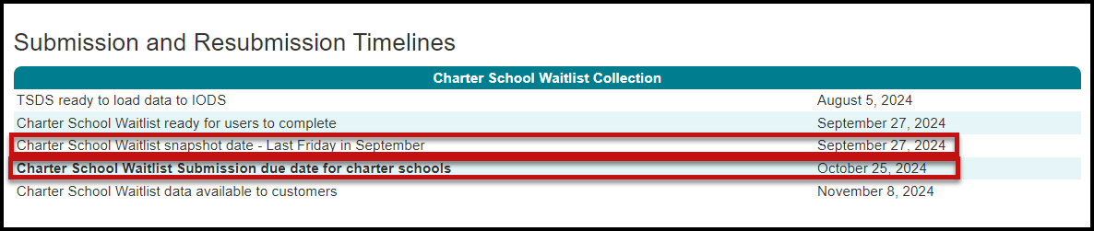

TSDS TEDS – Texas Education Data Standards

The data submitted through TSDS must be in XML format as defined in TWEDS (Texas Education Data Standards). The TWEDS is located on the TSDS website.

https://tealprod.tea.state.tx.us/TWEDSAPI/23/395/0/Overview

TWEDS Charter School Waitlist

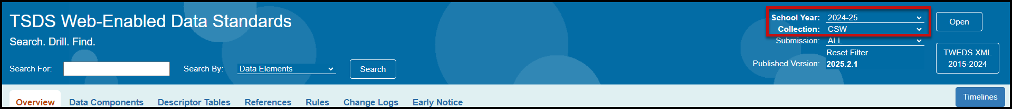

According to TEDS the LEAs (Local Education Agencies) are responsible for:

- Submitting current, complete, and accurate data required for each PEIMS and TSDS Collection
- Validating data per business rules and validations
- Correcting all errors during the validation process in a timely manner
- Delivering “fatal-free” corrected data on or before any due dates set by the ESC or TEA

TSDS – Core Access and User Roles

The TSDS PEIMS/Core application is only available to authorized ESC, district, and campus staff. A TEAL logon is required as well as access to the Texas Student Data System Portal. Different roles can be assigned to the user based on the access required.

- DMC LEA Data Monitor w/CSW Privileges – This role allows the user to monitor the data that has been loaded in the IODS. It allows the user access to L1.5 Filters, Descriptor Mapping, Search Data, and Reports.

- DMC LEA L2 Validations w/CSW Privileges – This role allows the user to schedule, run, and view L2 Validations (Fatals, Special Warnings, and Warnings) prior to promoting and validating the data in the actual TSDS submission.

- Core LEA Promoter w/CSW Privileges– This role allows the user to promote loaded data, validate (prepare) data and view submission data reports.

- Core LEA Completer (LEA) w/CSW Privileges – This role allows the user to promote loaded data, validate (prepare) data, complete (finalize) data and view reports at the district level.

- Core LEA Approver (LEA Superintendent) w/CSW Privileges – This role allows the Superintendent to request an extension for the submission. The Superintendent does not approve this submission.

- Core ESC Data Viewer w/CSW Privileges - This role allows the user at the ESC to view and monitor the submission.

TSDS – Core Pre-Requisites

- All data for the students on the waitlist, including the assigning of UIDs, must be entered in the LEA’s student software.

- The process (extracts) of moving required data through the API to the IODS must have been done. This process should be done daily, but LEAs should be able to process as needed for the collection.

- Level 1 Errors related to the Charter School Waitlist must be corrected.

Verifying CSW Data – Manage IODS in the DMC

The DMC (Data Management Center) allows LEAs to monitor and validate their data in the IODS (Individual Operational Data Store). All data is stored in the IODS prior to promoting it to the individual TSDS collections. Together the systems allow LEAs to synchronize near real time updates via the API between the source systems and their IODS, enable LEAs to perform more rigorous validations early in the submission process, and provide LEAs the ability to search and view data in the IODS.

- Log into TEAL and select Texas Student Data System Portal.
- On the Home screen select Manage IODS.

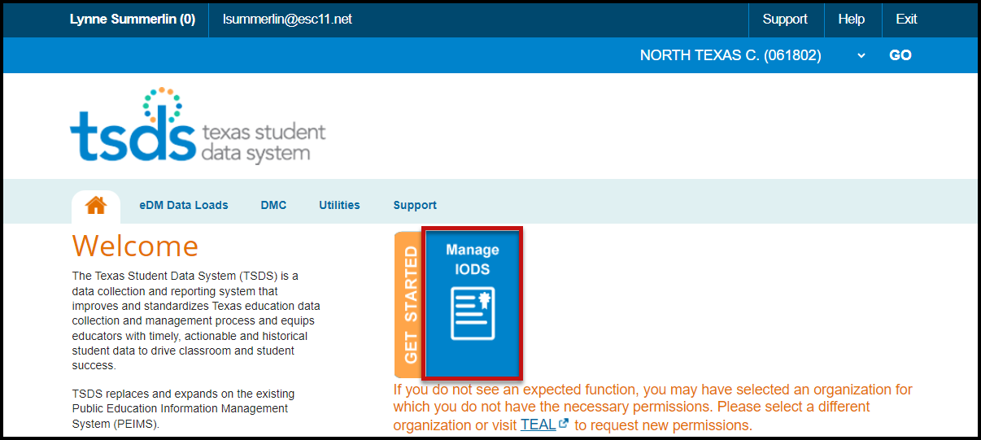

- The Welcome to the DMC screen appears:

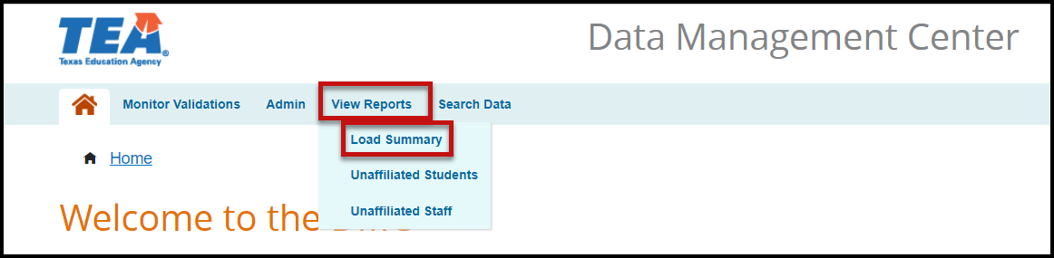

- Under View Reports, select Load Summary. Verify that data has been loaded for the Education Organization and Student Application Domains. If the LEA is not reporting a waitlist, the Education Organization will be the only domain that will be required for the collection.

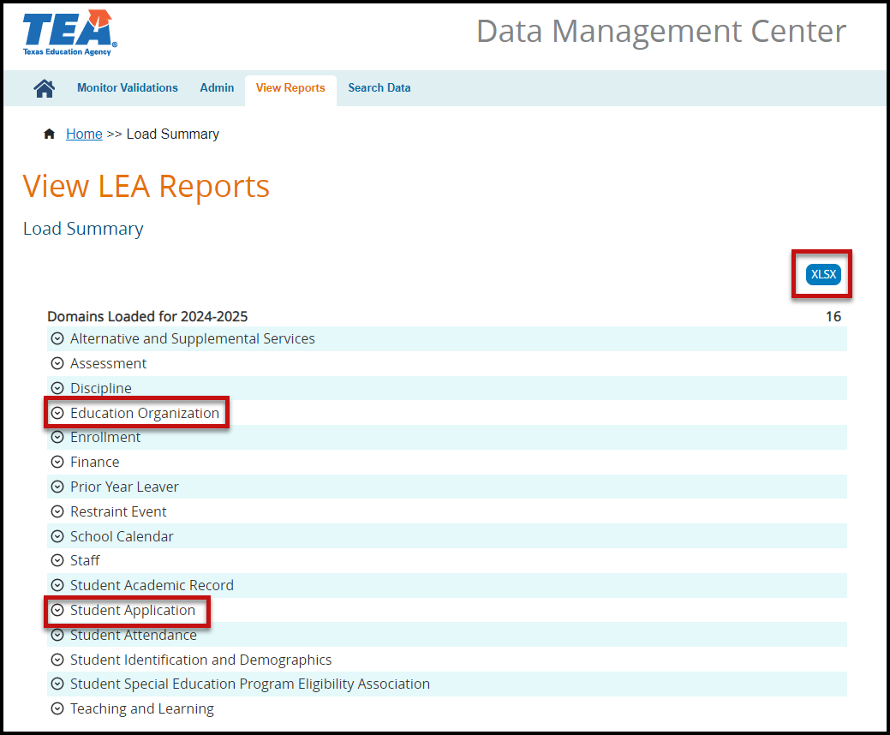

- Click the down arrow icon next to the Domain name to view the number of records loaded and the last date the records were updated. If no records are listed for the entities, the LEA must check to determine why data is not being sent through the API.
- The data can be downloaded by clicking the XLSX button.

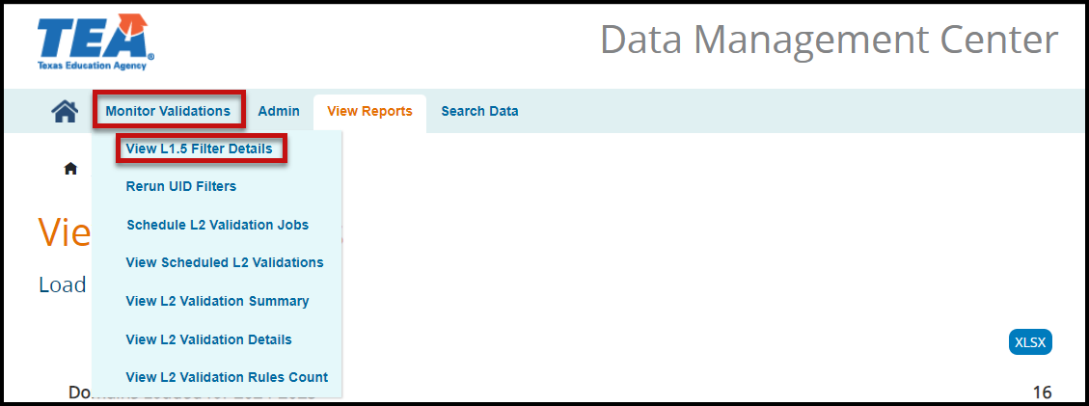

- Under Monitor Validations select View L1.5 Filter Details. The View L1.5 Filter Details screen appears.

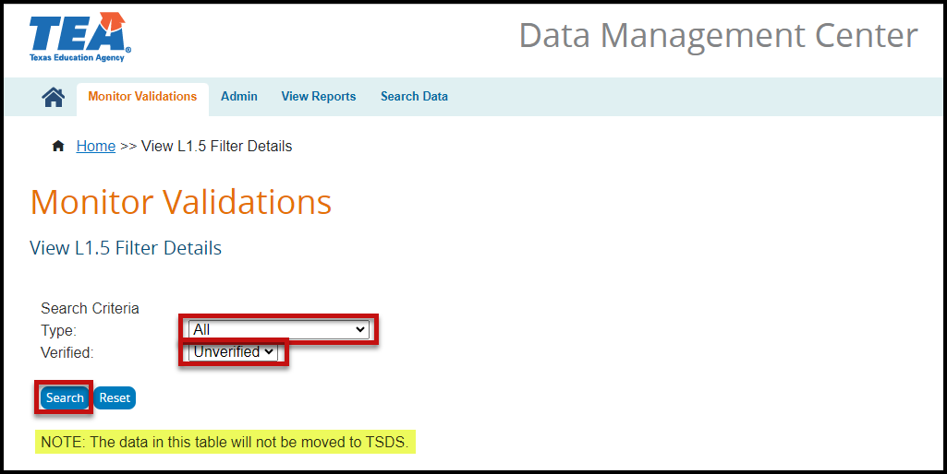

- Select All for the Type under Search Criteria.
- Select All for the Unverified status under Search Criteria.
- Click Search. If there are any L1.5 filters that need to be verified a list will appear. For the CSW collection LEAs will need to verify any L1.5 filters for UID - Student and possibly the Descriptor Values.
- If there are any L1.5 Filters, make any corrections that need to be made in the software, and mark them as verified.

Note: Any data in this table will not be moved to TSDS. L1.5 Filters do not necessarily mean there is an error in your data. L1.5 Filters are just pieces of data that do not meet the requirements for submission to TSDS.

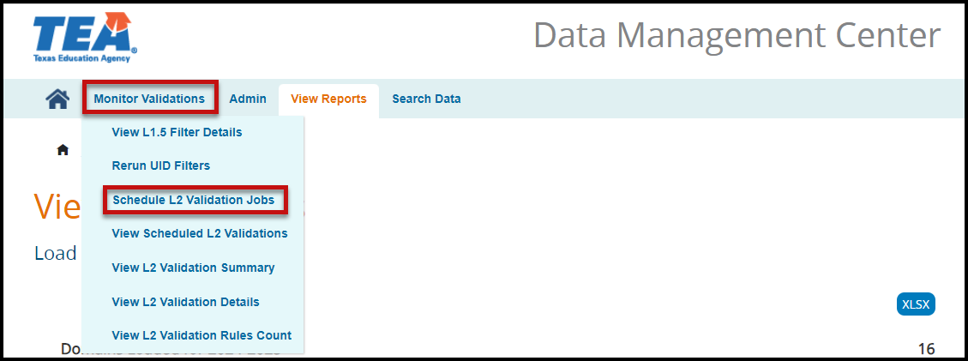

- Under Monitor Validations select Schedule L2 Validation Jobs. The Run L2 Validations screen appears.

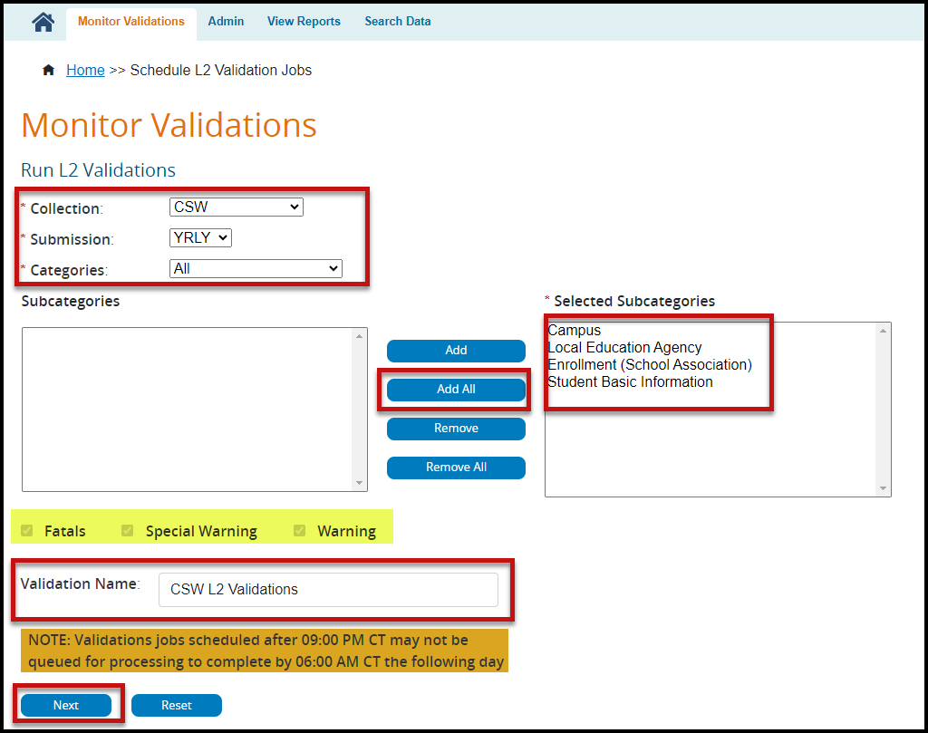

- Select CSW from the Collection pull-down menu.
- Select YRLY from the Submission pull-down menu.
- Select All from the Categories pull-down menu.
- Move all the Subcategories to the Selected Subcategories by clicking the Add All button.
- Enter a Validation Name.
- Click Next. The Confirm Validation Request screen appears.

Note: The selections for Fatals, Special Warning, and Warning are grayed out. The process will run all three validations.
Validation jobs scheduled after 9:00 PM may not be queued for processing to complete by 6:00 AM the following day.

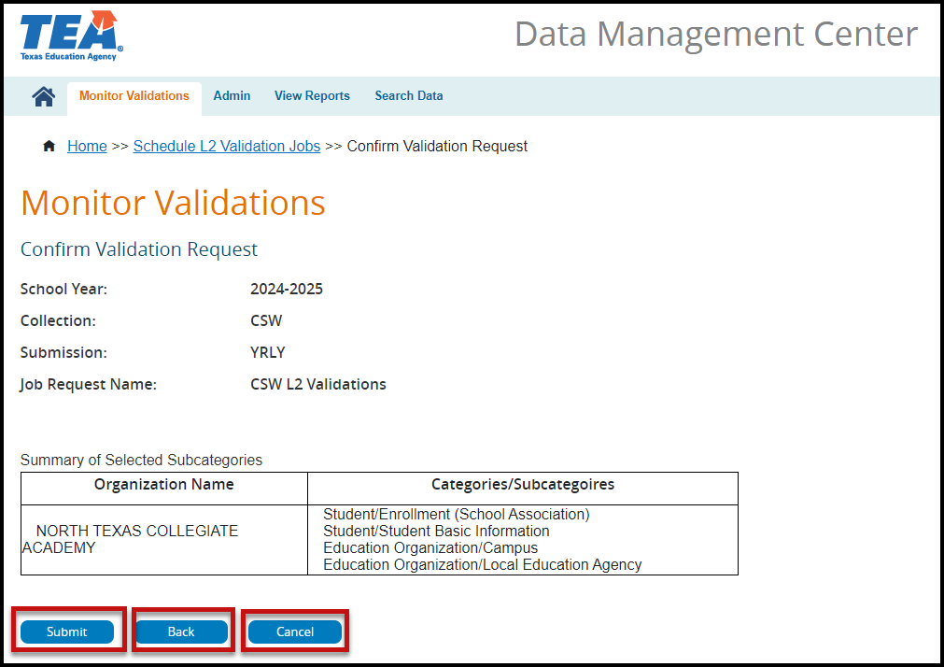

- Verify all the information on the screen is complete.
- Click Submit to continue scheduling the L2 Validations.
- Click Back to return to the previous screen.
- Click Cancel to discontinue the process.

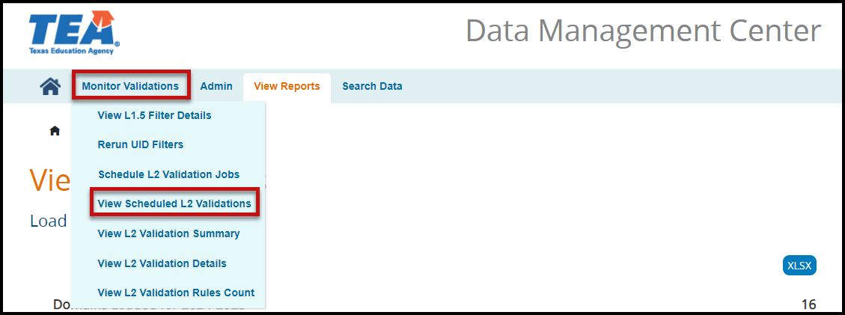

- Under Monitor Validations select View Scheduled L2 Validations to view the progress of the scheduled L2 Validations. The View L2 Validation Requests Summary screen appears.

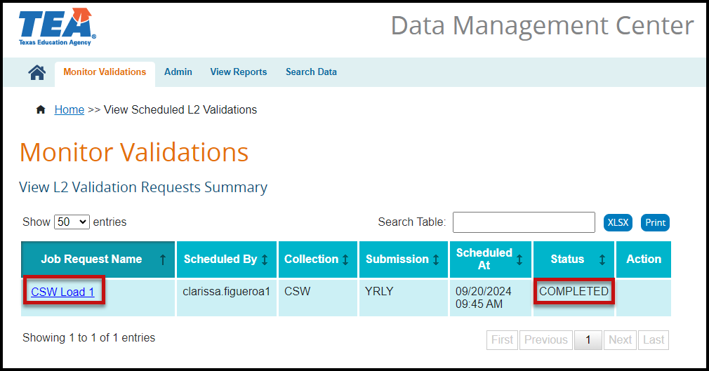

The screen lists the Job Request Name, Scheduled By, Collection, Submission, Scheduled At (DTS), Status, and Action. The columns can be sorted by selecting the arrow icon in the header next to the item to be used for the sort.

The number of entries shown can be changed using the pull-down menu for Show entries.

Items on the table can be searched using the Search Table feature.

The data can be Printed or downloaded as an XLSX.

- Once the status shows Completed, click the Job Request Name (hyperlink) to view the number of errors by Category and Subcategory.

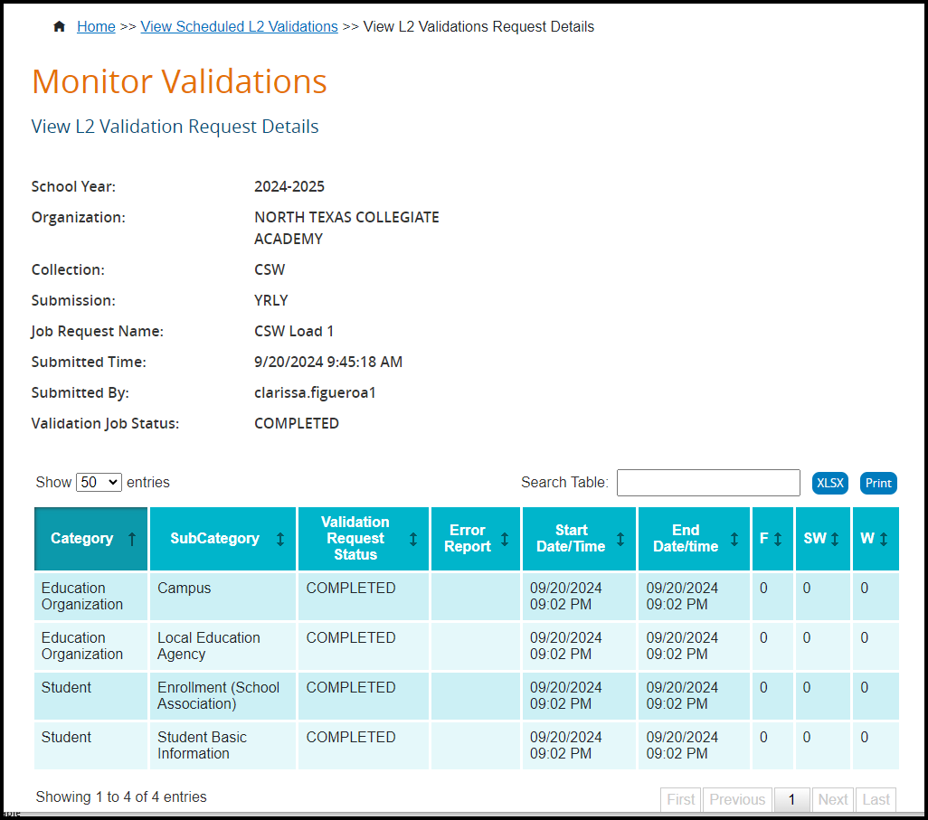

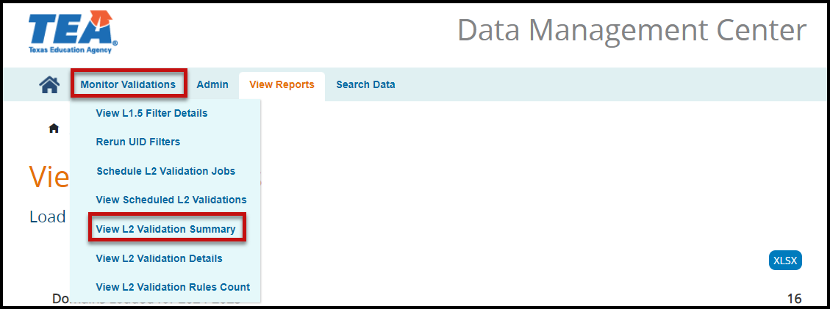

- Under Monitor Validations select View L2 Validation Summary to view the L2 Validation Summary. The View L2 Validation Summary screen appears.

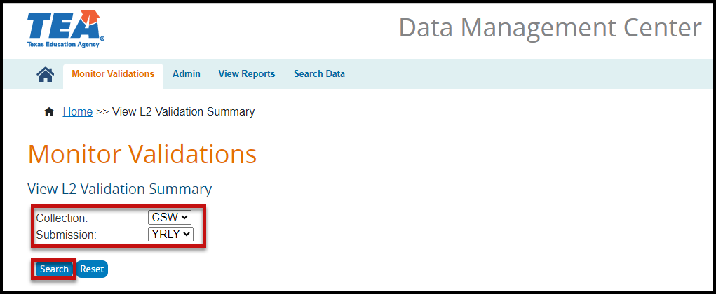

- Select CSW from the Collection pull-down menu.
- Select YRLY from the Submission pull-down menu.
- Click Search. The Summary screen appears listing the Collection, Submission, Category, Subcategory, Last Successful Run (DTS), Details, number of F(atals), S(pecial Warnings), and W(arnings).

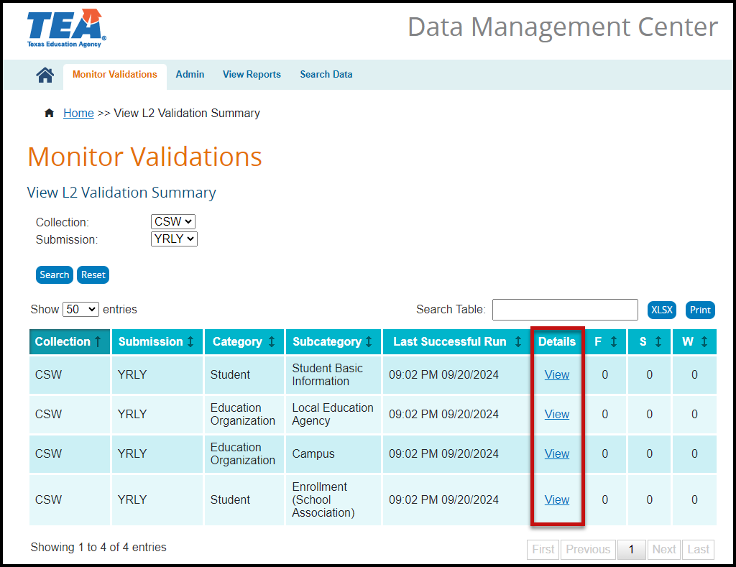

- Click the View hyperlink to view the actual errors for each subcategory.

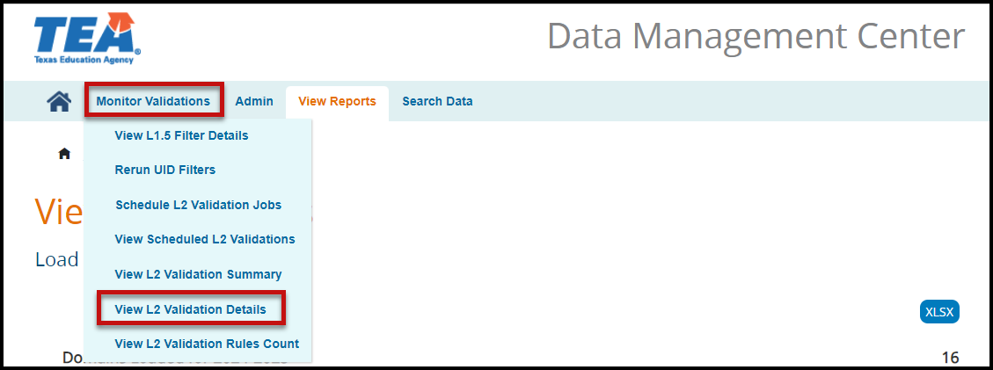

- Under Monitor Validations select View L2 Validation Details to view the L2 Validation error Details. The View L2 Validation Details screen appears.

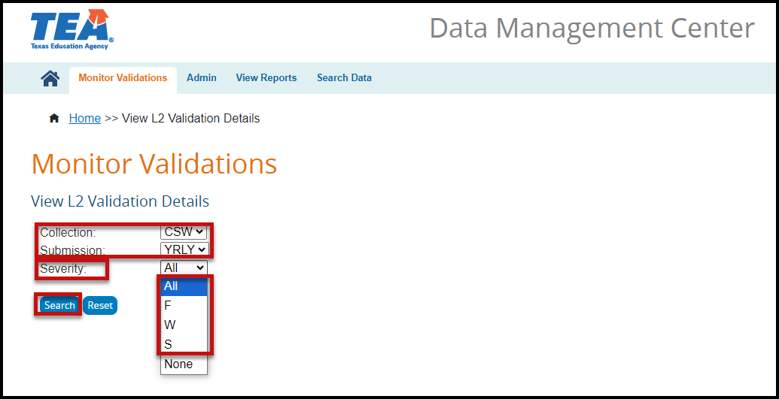

- Select CSW from the Collection pull-down menu.
- Select YRLY from the Submission pull-down menu.
- Select the Severity from the pull-down menu.
- Click Search. A screen will appear with the selected Error Details.

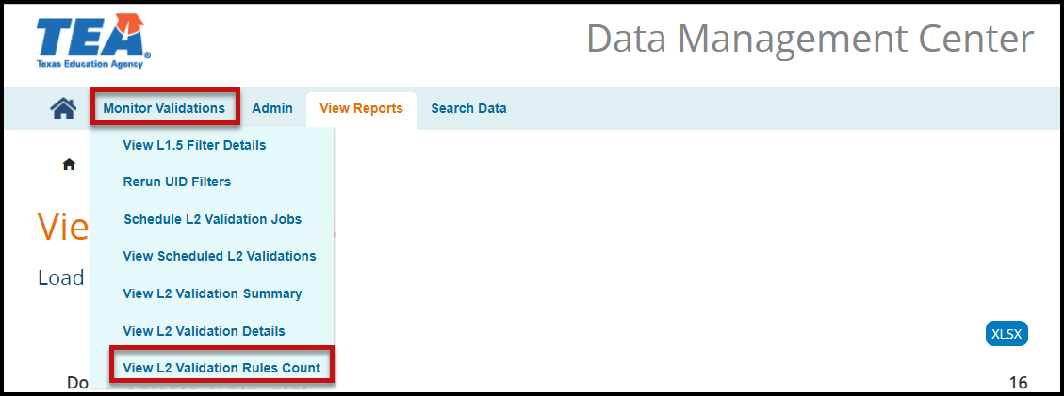

- Under Monitor Validations select View L2 Validation Rules Count to view the L2 Validation errors by count, no details. The Count L2 Validation Rules screen appears.

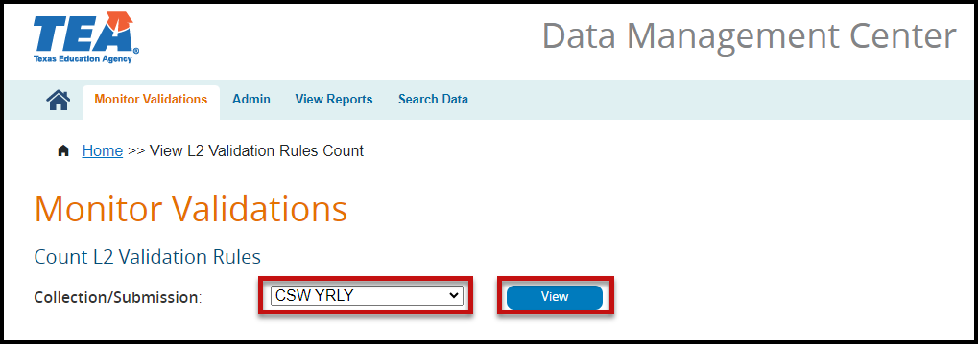

- Select CSW YRLY from the Collection/Submission pull-down menu.
- Click View. A list of errors by error number, description, and count appears.

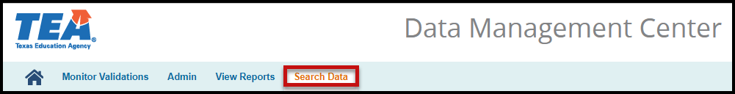

- From the menu bar, select Search Data. The Search Landing Zone (IODS) screen appears.

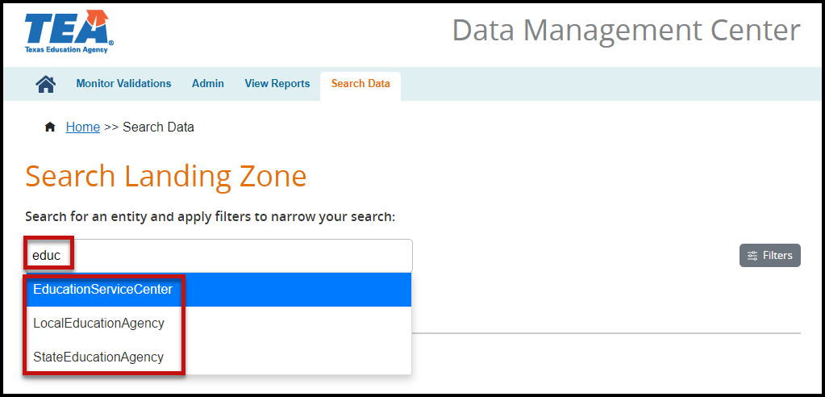

- Enter the name of the entity you are searching for.

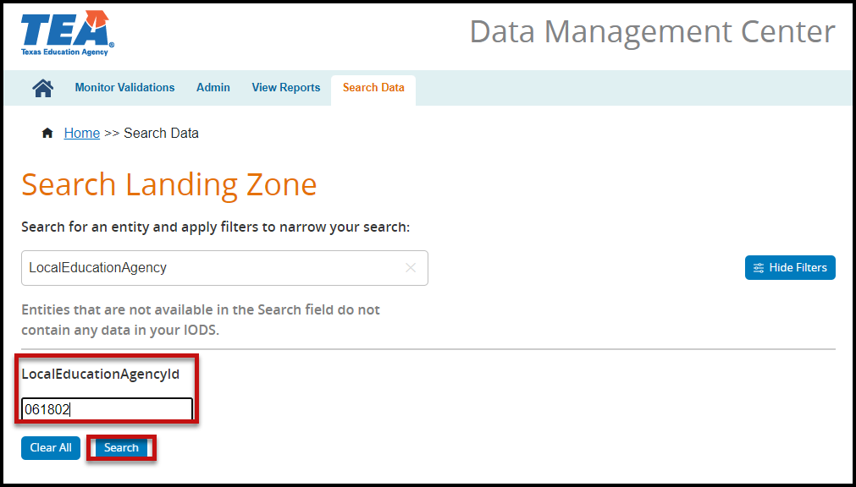

- Enter the information for the filter(s).
- Click Search. A table appears with an option to View the JSON (IODS) data.
- Click View to view the data in the IODS in TSDS Ed-Fi format.

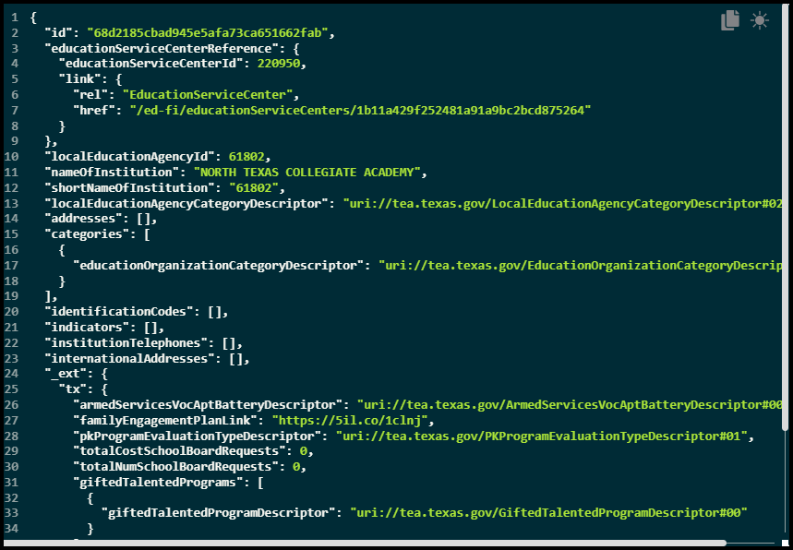

Promoting CSW files – Core Collection Promote Loaded Data

The eDM Promote Loaded Data tool allows users to promote data that has been loaded and batched.

- Log in to TEAL and select Texas Student Data System Portal.
- On the Home screen select Core Collection > Promote Loaded Data.
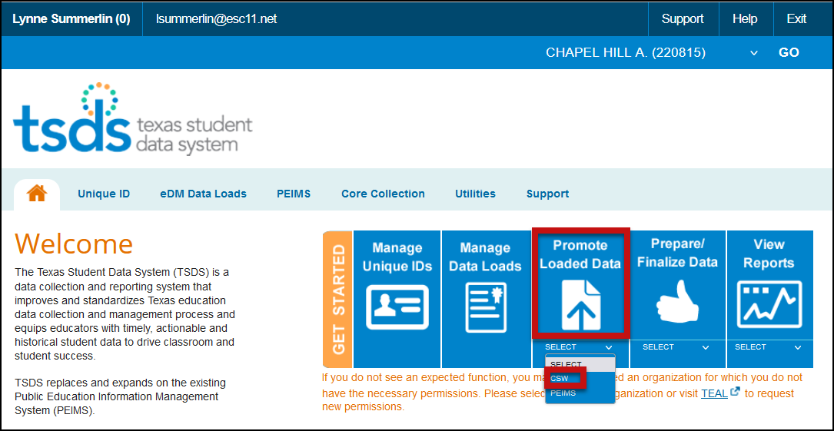
- The Data Promotion screen appears:

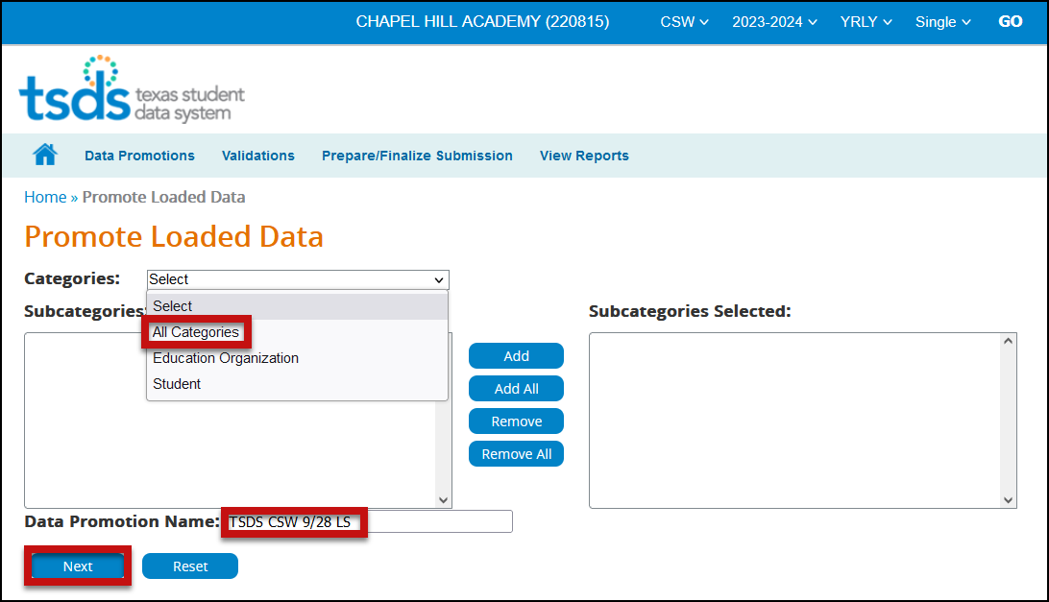

- Verify the correct submission is selected. If not, select it from the pull-down menu and click GO.
- From the Categories pull-down menu, select All Categories or the individual categories to be promoted. If individual categories are selected user may also select individual subcategories.
- Enter a Data Promotion Name.
- Click Next to continue or Reset to clear selections.
- The Confirm Data Promotion screen appears:
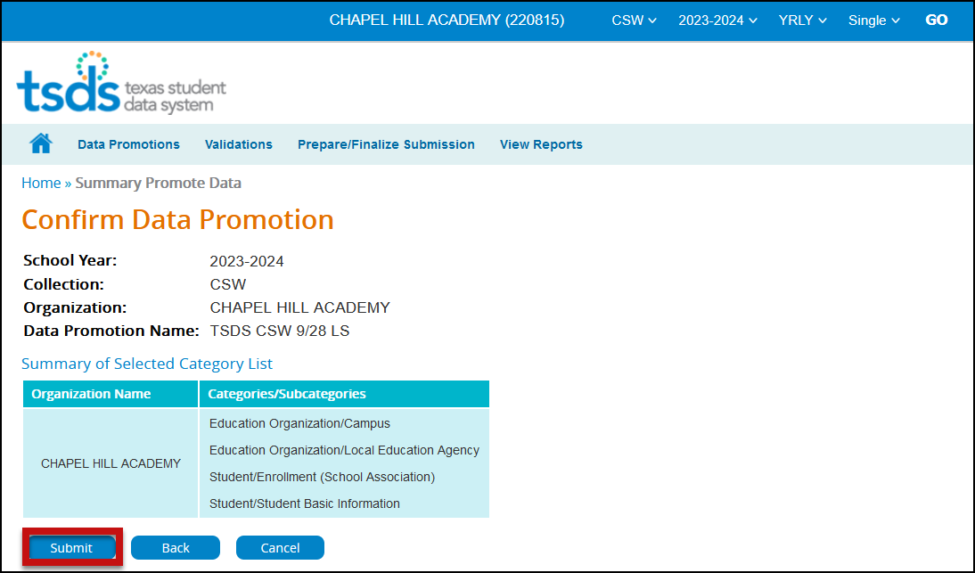
- Verify the Categories/Subcategories
- Click Submit, Cancel, or Back.
- The Monitor Data Promotions screen appears:

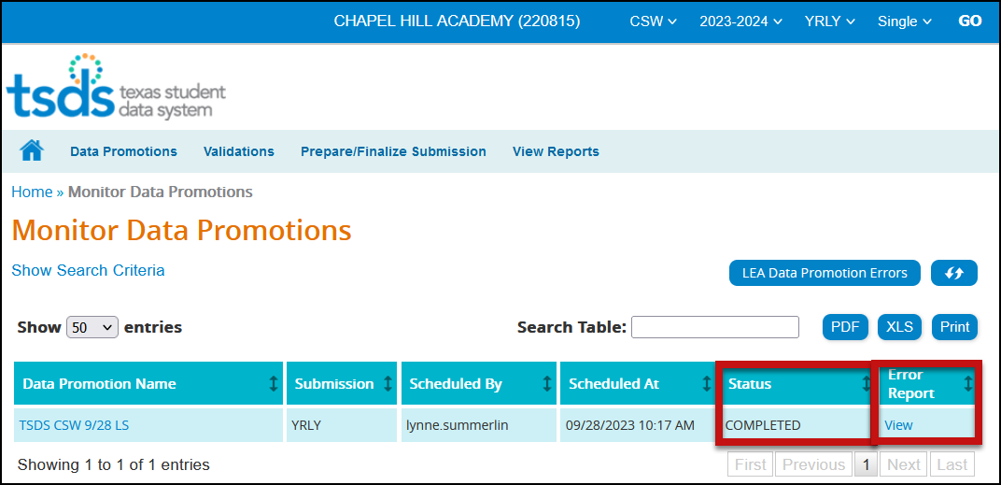

- This screen shows the status of the data promotion, promotion error reports, and a confirmation message that the data was promoted.
- To view any promotion errors, click the View link under Error Report or click the LEA Promotion Errors button.
- The Data Load Error Report by Job screen appears:

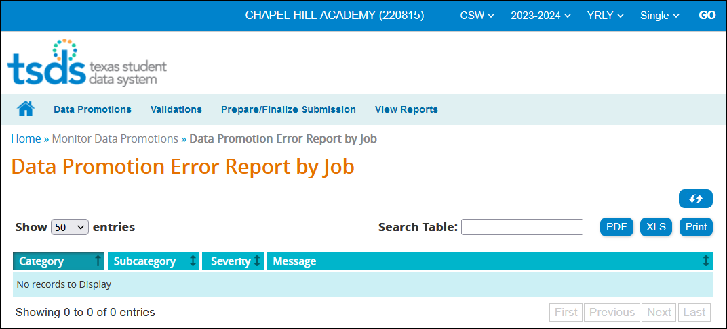

- This screen will list any errors by Category, Subcategory, Severity, along with the error message. Errors can be saved as a PDF or XLS file or can be printed by selecting the appropriate button.

Validating CSW files – TSDS Core Promote Loaded Data>Validations

The eDM Promote Loaded Data tool also allows users to validate data that has been promoted in TSDS. This is where the district will be able to view the Fatals, Warnings, and Special Warnings for the submission.

- Log in to TEAL and select Texas Student Data System Portal.
- On the Home screen select Promote Loaded Data. Select the Validations tab > Validate Submission Data.

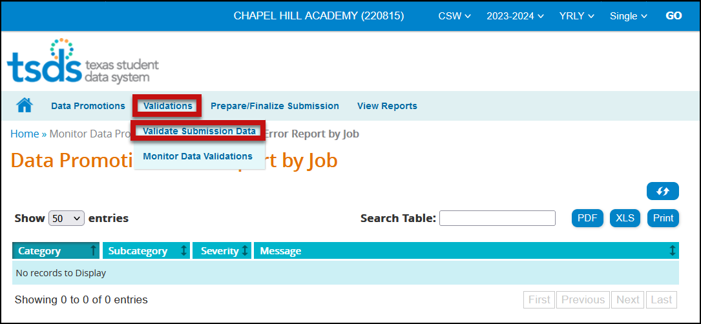

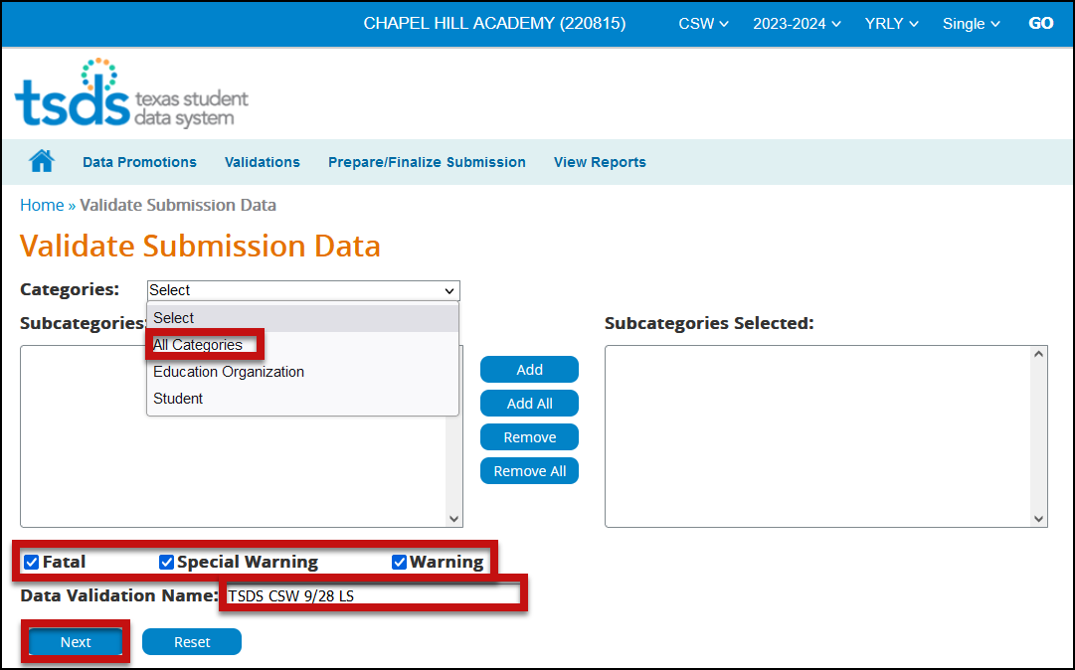

- From the Categories pull-down menu, select All Categories or the individual categories that are to be validated.
- Select the type of validation (Fatal, Warning, Special Warning).
- Enter a Validation Name.

- Click Next to continue the process or Reset to clear all options.
- The Confirm Data Validation screen appears:

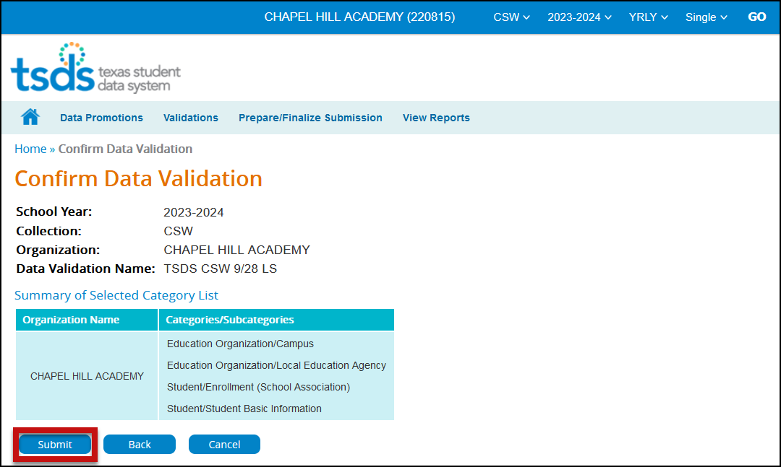
- Verify the Categories/Subcategories
- Click Submit, Cancel, or Back.
- The Monitor Data Validations screen appears:

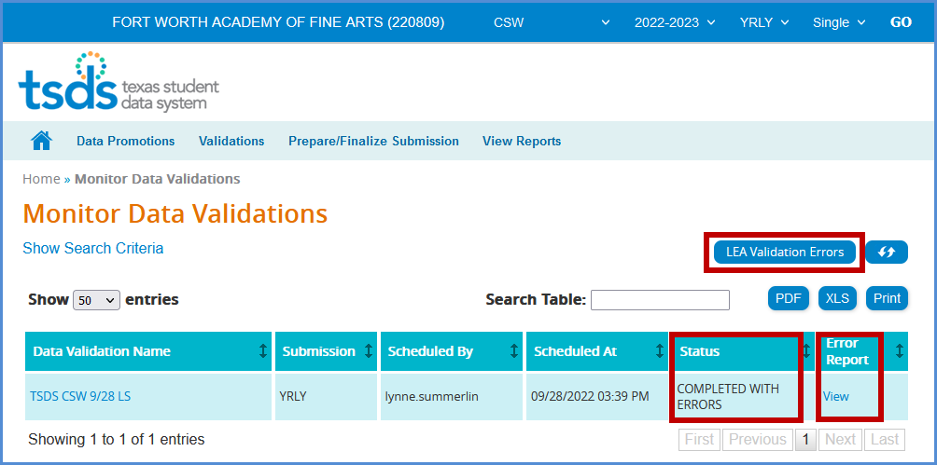

- This screen shows the status of the data validations, validation error reports, and a confirmation message that the data has been submitted.

- To view validation errors by job, click the LEA Validation Errors button or View und Error Report.

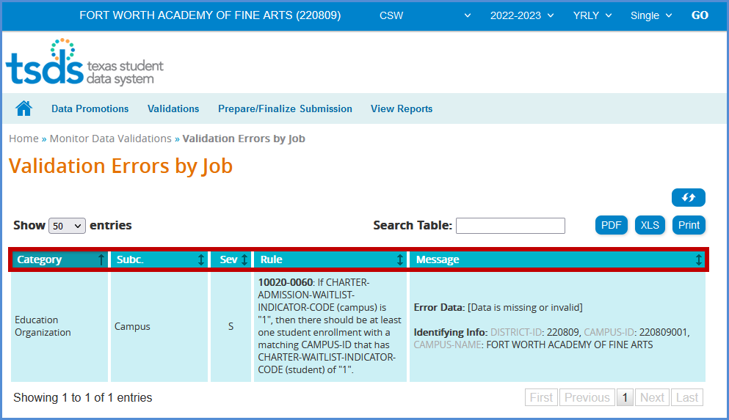
- This screen will list any errors by Category, Subcategory, Severity, along with the error message.
- Errors can be sorted by the individual columns. The errors can also be saved as a PDF or XLS file or can be printed by selecting the appropriate button.
- The Search Table option can be used to search the errors by any field such as Rule Number, Student UID, specific Category or Subcategory, etc.

Note: It is recommended that the district use the Delete Utility in TSDS>Manage Data Loads to clear the incorrect data from the ODS prior to uploading the new files.

View Reports – CSW0-100-001 CSW Roster Report

Report must be run and verified prior to and after completing the CSW data submission.

To access the reports:

- Log in to TEAL and select Texas Student Data System Portal.
- On the Home screen select CSW under View Reports. Click View Reports.

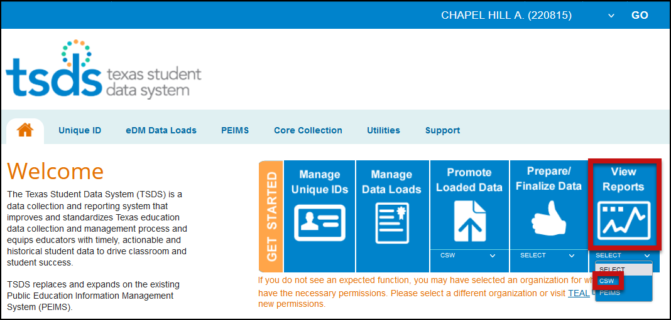

- Or reports can be accessed in Core Collection > CSW > View Reports.

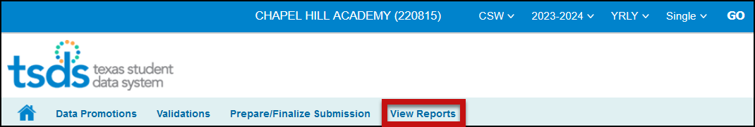

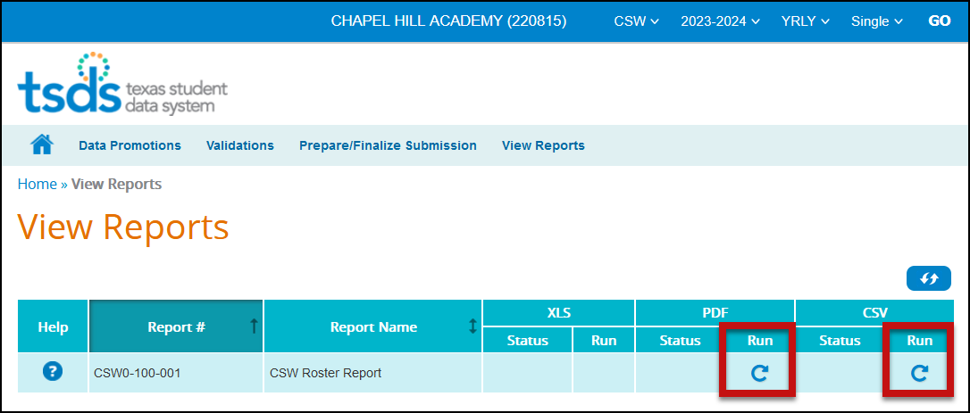

- Under View Reports, click the arrow in the Run column for the appropriate report.

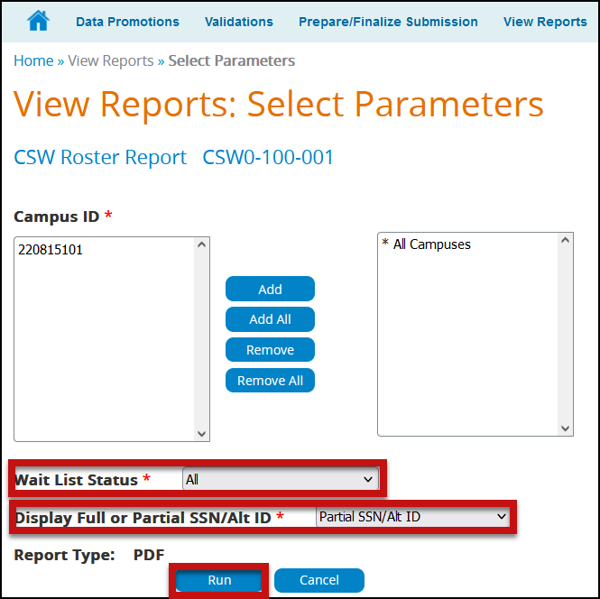

- The CSW Roster report requires Parameters be selected. Select the appropriate parameters and click Run.
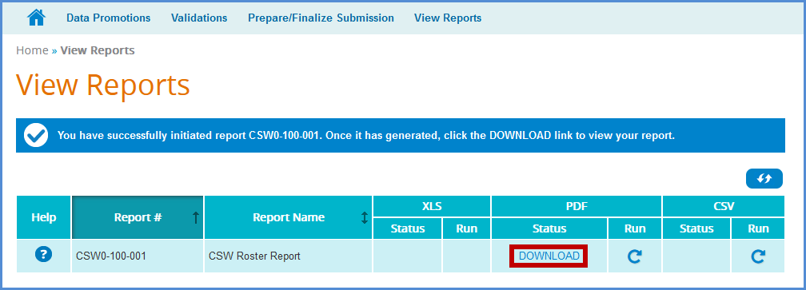

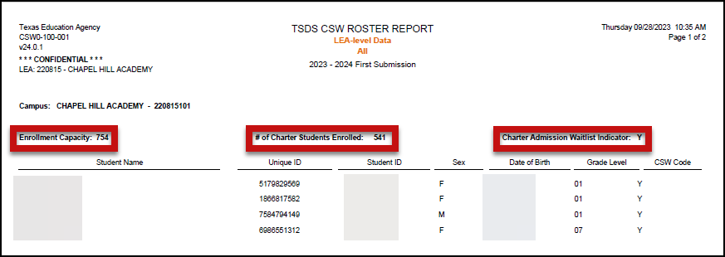
- Click Download to view the reports.

TSDS – Core CSW Prepare/Finalize Process

Once data has been validated and is fatal free, the district will prepare and finalize the data which will include completing the process.

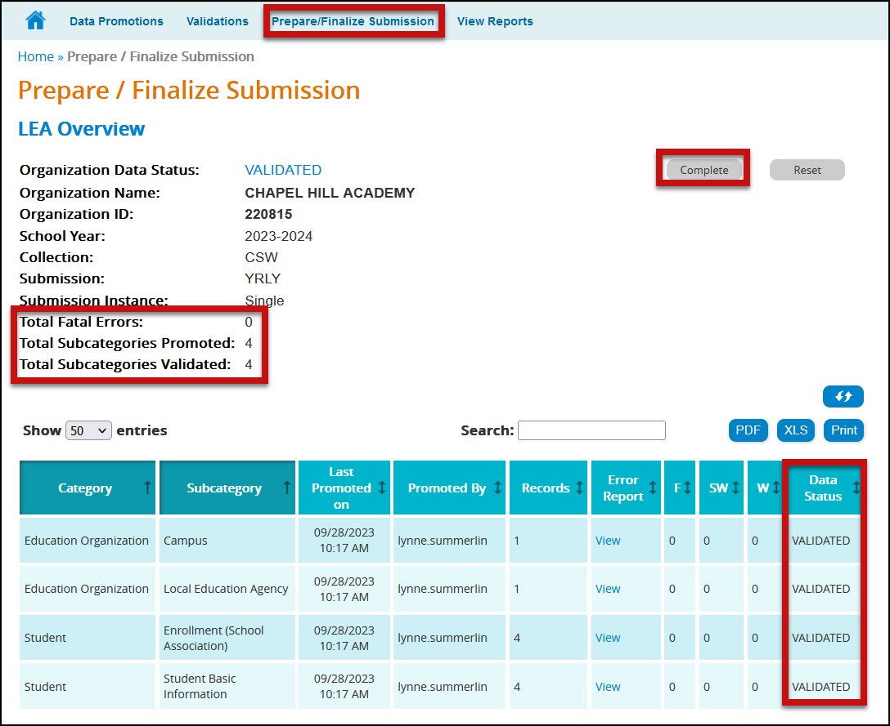

- Click Complete. This prompts another validation of the data. A Completion Process Status message appears showing the progress.
- If there are no fatals, the data returns with a status of VALIDATED
- If there are no fatals, the data returns with a status of COMPLETE.
- A message appears to check the box to acknowledge the data is promoted, validated, reviewed for accuracy and authenticity, and all special warnings and warnings have been reviewed and confirmed.

Check the box and click CONFIRM.

Reset Submission

If you need to reset the data to its original state after completion, click the Reset button. You can reset your submission until TEA’s submission due date. Once the submission is marked complete, the data status is set to LEA – DATA COMPLETE and further edits to the data are not available.

Charter School Waitlist Resources

Links:

https://tealprod.tea.state.tx.us/TWEDSAPI/23/395/0/Overview
TWEDS Charter School Waitlist

https://tea.texas.gov/texas-schools/texas-schools-charter-schools/charter-schools
TEA Charter Schools Website

charterschools@tea.texas.gov
TEA Charter School Division Email

https://tea.texas.gov/texas-schools/texas-schools-charter-schools/charter-student-admission-application-forms
Charter Student Admission Application Forms

Knowledge Base Articles:

TSDSKB-606 TEAL Roles for Core Collections

TSDSKB-613 Charter School Waitlist FAQs

ESC Region 11 grants permission to attendees of this session to reproduce and distribute designated resources and materials provided during the presentation.

